Kevin Hinton and Taft Sandbakken
CS 470
Grid Lab Report

Visualizations:

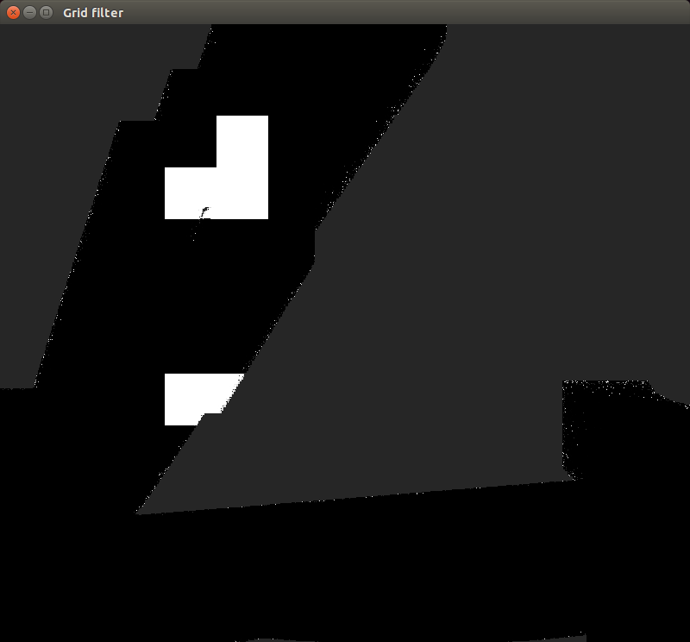
This figure shows the tanks going to the bottom left corner, then moving to the right corner. After that it shows them making their way back up to explore the rest of the map.
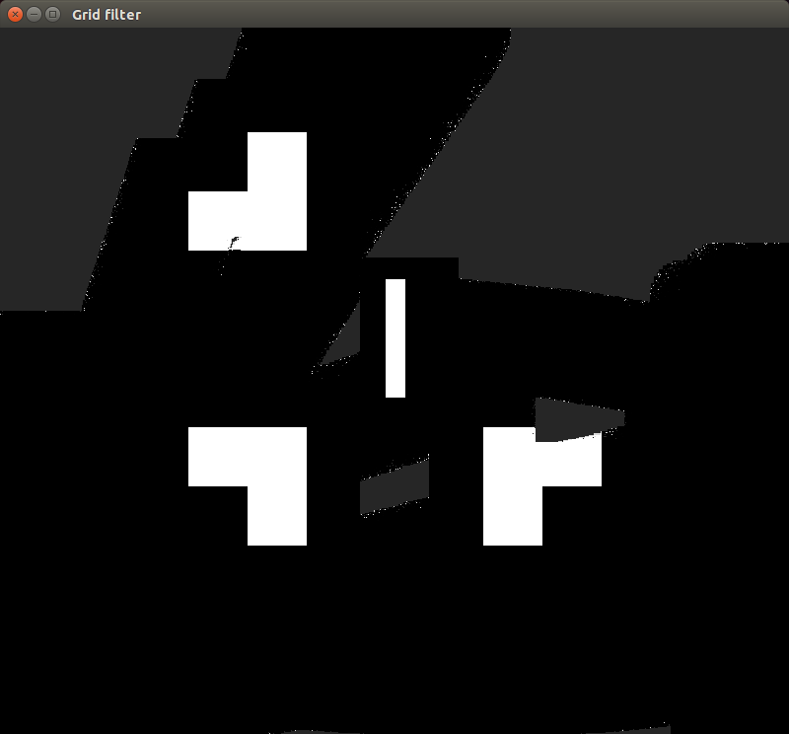

This figure shows the map after the tanks have more horizontal traversals of the map. It shows a few missing spots on the map but an overall good percentage.
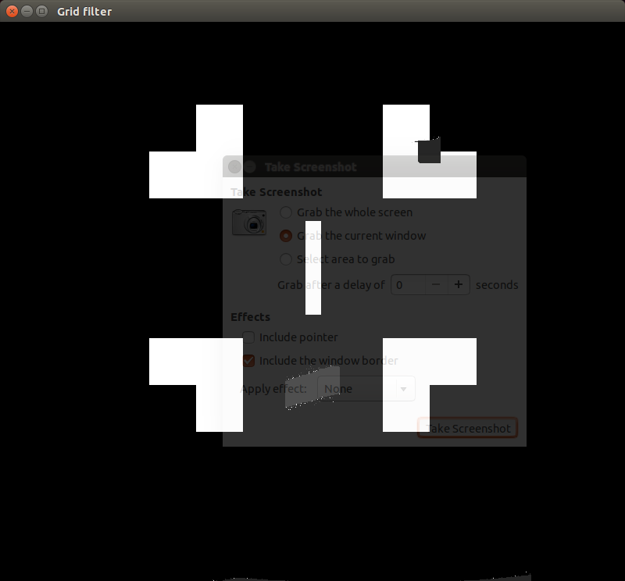

This figure shows the map after the traversals were over. It shows just one main missing patch near the center and one in the top right obstacle. Overall this was a very high percentage of discovery.

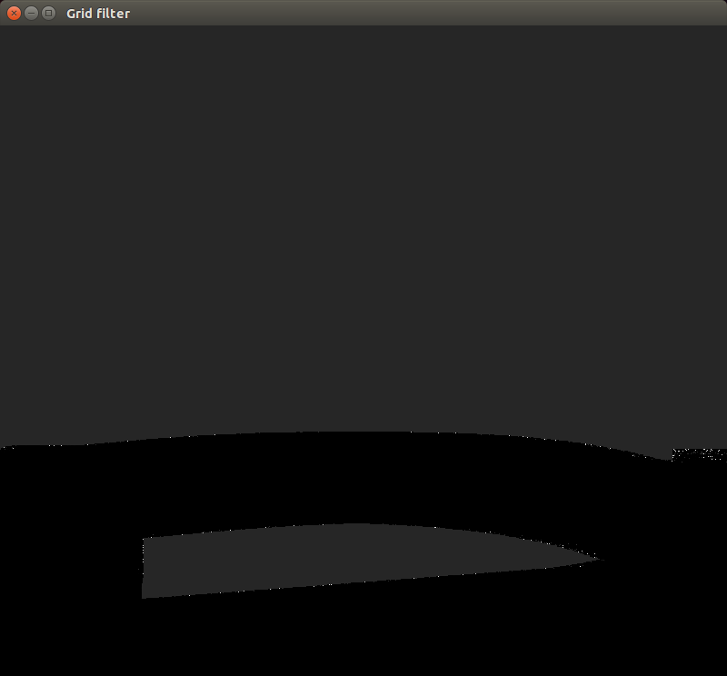

This figure shows a second map being discovered by the tanks. It starts with the tanks on the bottom combing the lowest rows.
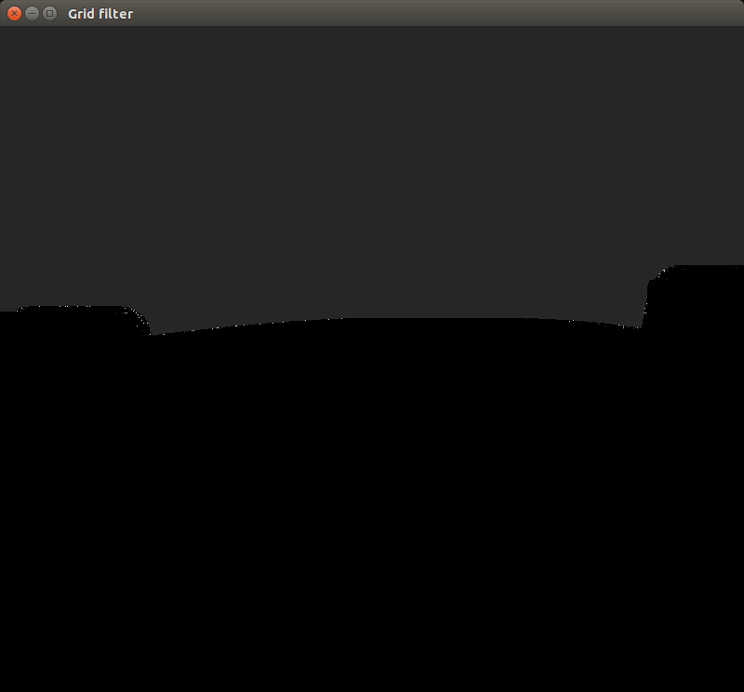

This figure shows the map after more time passes and the tanks do a great job of covering all of the bottom half of the map.

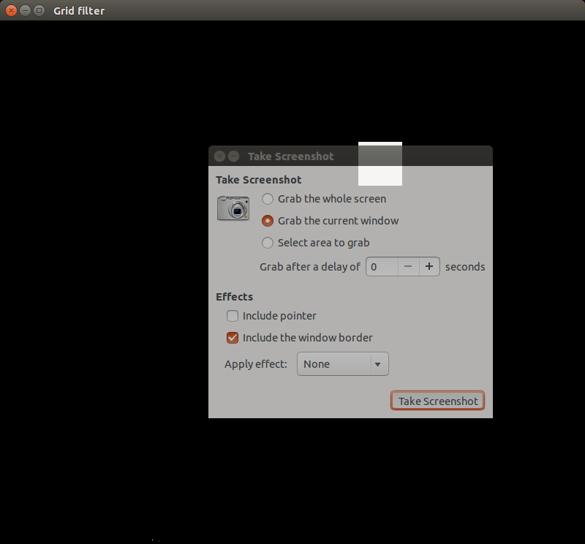

This figure shows the map after the entire area is covered by the tanks. The tanks proved to be very effective in a world with very few obstacles. There is very little area that didn't get fully discovered.

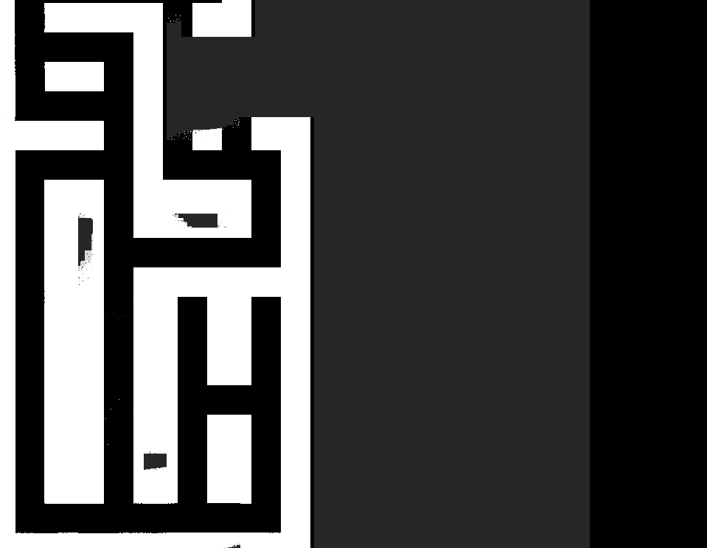
This figure shows the end of traversing a more difficult map, the maze. It shows that the tanks did a great job of coving the areas that can be hard to reach because of the maze-like structure of this map.

Searching the World:
The searching of the world consisted of combing the map with a line of tanks. It worked by sending all of the tanks to one corner, then aligning them in a vertical line along one side of the map. The tanks would then travel horizontally to the other side, combing the map. Then the tanks travel to the other section of unexplored map, where they follow the same pattern of combing the map in a vertical line. This worked very well for the simple maps. Almost all of the map was discovered with a remarkable success rate of discovering where the obstacles were. On the more complicated maps, such as the maze map, the tanks did a good job of exploring a large amount of the map. We were able to run 10 tanks fairly well with a slight lag but able to cover all parts of the quicker than with fewer tanks.

Varying Parameters:
Varying parameters can result in many different outcomes, most of which is incorrect readings. As the grid increases the time to process increases as noisier outcomes results in incorrect readings and more false positives or false negatives. If you have an incorrect model for what noise comes back then your are even more likely to get false positives and if you have moving targets the data could be outdated or not even there any more. As tested when the true positive or true negative rates were lowered it took more readings to evaluate to correct results, and in cases where limited readings were taken speckles of white marked the borders.

Live Opponent:
The current algorithm the tanks use for traversing the world would do really poorly against live opponents. Most likely, the tanks would get destroyed halfway through the process and obtain a poor amount of information for future tanks. A better approach could be to do a breadth first search of the map, so that by the time the enemy tanks are found, a good portion of the map would be discovered, and it would be more important parts of the map. Also, that would make it much less random when the enemy tanks would be found.

Summary of Learning:
One thing that was learned was how effectively a map can be fully discovered by short sighted tanks in a limited time. Even with noise in the sensors, great accuracy can be reached given the formulas as discussed in class. It was amazing just how accurate it could be assuming the tank had time to see the same spot for a few seconds. It was also impressive that ten tanks could be deployed at once without a major drop in performance. Each tank does a lot of processing but it was efficient enough for ten of them at once.

Time Spent on Lab:
Kevin Hinton:
Taft Sandbakken: 7

